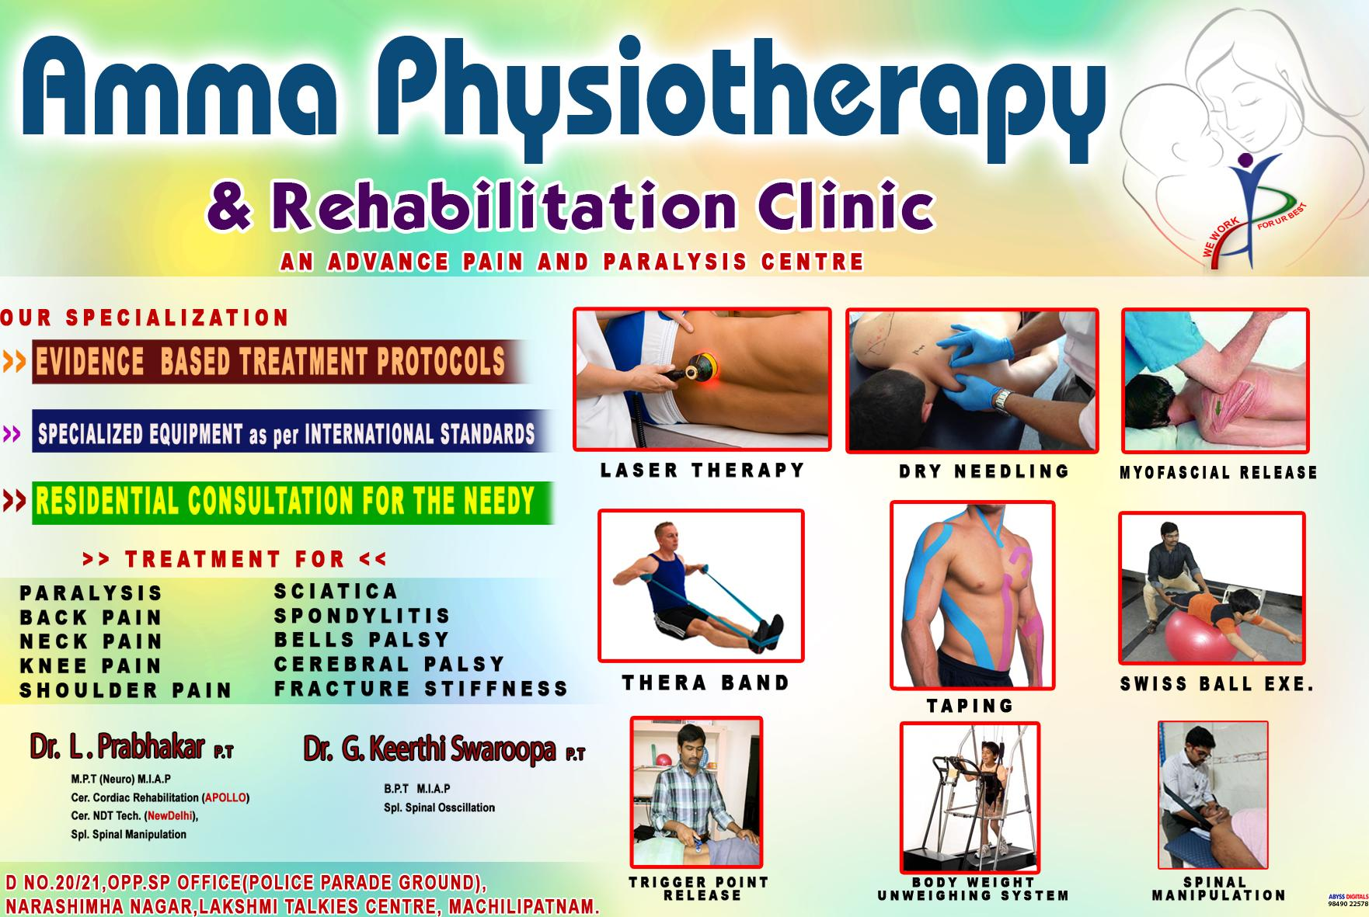

**AIN AND PARALYSIS CENTRE**

Spl. Spinal Osscillallon

M.P.T (Mourn) M.I.A.P

Car. Cordlac Rehabilitation (APOLLO) Car. NOT Tech. (Newrialhi),

Sal. Spinal Manipulation

**ow-**

**Ammo Physiotherapy**

**itation Clinic**

**OUR SPECIALIZATION**

**EVIDENCE BASED TREATMENT PROTOCOLS**

**SPECIALIZED EQUIPMENT** as per **INTERNATIONAL STANDARDS**

**RESIDENTIAL CONSULTATION FOR THE NEEDY**

|  |  |  |  |  |
| --- | --- | --- | --- | --- |
| **» TREATMENT FOR «** | | |  |  |
| **PARALYSIS** |  | **SCIATICA** |
| **BACK PAIN** |  | **SPONDYLITI** | S |  |
| **NECK PAIN** |  | **BELLS PALS** | Y |  |
| **KNEE PAIN** |  | **CEREBRAL** I | **ALSY** |
| **THERA BAND** |
| **SHOULDER** | **PAIN** | **FRACTURE 1** | **TIFFNESS** |

**Dr. L • Prabhakar P.T Dr. G. Keerthl Swaroopa P.T**

D NO.20121,0PP.SP OFFICE(POLICE PARADE GROUND), **TRIGGER POINT**

NARASHIMHA NAGAR,LAKSHMI TALKIES CENTRE, MACHILIPATNAM. **RELEASE**

>>

**LASER THERAPY**

**DRY NEEDLING**

**TAPING**

MYOFASCIAL **RELEASE**

**SWISS BALL EXE.**

**BODY WEIGHT
  
UNWEIGHING SYSTEM**

**SPINAL MANIPULATION ==**